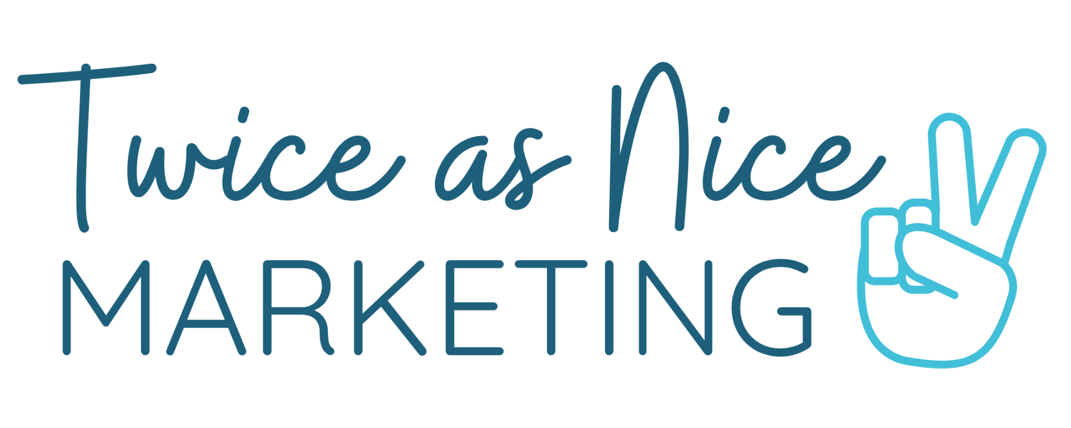

**Simple Marketing Plan Template**

This simplified template is inspired by [Allan Dib’s *One-Page Marketing Plan*](https://www.amazon.com/shop/influencer-303f6e51/list/1HAX6F5SZMQJH?ref_=cm_sw_r_cp_ud_aipsflist_M2XBH3M0YHD489YEG0V1) framework, divided into three phases: Before, During, and After. Use this template to create a concise, actionable marketing plane & strategy for your business.

### **Phase 1: Before (The Marketing Groundwork)**

**1. Ideal Customer:**Define your ideal customer. Get specific. What keeps them up at night?

* Demographics: Age, gender, location, income level
* Psychographics: Interests, challenges, values

**2. Message:**What problem are you solving? What’s your unique solution? What is the result that your customer will experience?

* Pain Points:
* Unique Selling Proposition (USP):
* Key Message:

**3. Media:**Where does your ideal customer spend time? How will you reach them?

* Social Media Platforms:
* Email Marketing:
* Advertising Channels:
* Business Partners:

### **Phase 2: During (Generating Leads)**

**4. Lead Generation Plan:**How will you capture attention and build interest?

* Lead Magnet (e.g., free guide, checklist, webinar):
* Landing Page:
* Lead Collection Method (e.g., forms, CRM):

**5. Nurture Process:**How will you warm up leads?

* Email Sequence:
  + Welcome Email
  + Value-Adding Emails (e.g., tips, case studies)
* Social Media Engagement Strategy:
  + Retargeting Ads
* Limited Free Trial

**6. Sales Conversion:**How will you convert leads to customers? What is your sales process?

* Sales Funnel/Process:
  + Awareness → Consideration → Decision

#### ***Awareness:***

* *A small business owner sees your Instagram Reel explaining "3 Reasons Your Social Media Isn't Converting."*
* *You include a CTA to download your free guide, The Ultimate Small Business Marketing Foundation Guide.*

#### ***Consideration:***

* *After downloading the guide, they receive a series of nurturing emails:*
  + *Email 1: Welcome and link to a helpful blog post.*
  + *Email 2: A client success story detailing how your social media strategy led to increased engagement and sales.*
  + *Email 3: A CTA to book a free 30-minute consultation.*

#### ***Decision:***

* *During the consultation, you outline how your $750/month social media management service can save them time and increase their reach.*
* *They sign up for a 3-month package.*

### **Phase 3: After (Building Loyalty)**

**7. Delivery and Delight:**How will you deliver value and exceed expectations?

* Product/Service Delivery Plan:
* Customer Onboarding Process:
* Follow-Up:

**8. Retention:**How will you keep customers coming back?

* Loyalty Program:
* Exclusive Offers for Repeat Customers:
* Regular Check-Ins or Surveys:

**9. Referrals:**How will you encourage referrals?

* Referral Program or Incentive:
* Testimonials and Reviews:
* Community Engagement: